

Functional Design Document

MSM API https POlist

Version:

|  |  |
| --- | --- |
| Customer Name | IT |
| Document Author | *EmmaPeng* |
| Author’s Email / Phone | [*emmapeng@eslite.com*](mailto:emmapeng@eslite.com) |
| Creation Date | *2023/12/22* |
| Last Updated | *2023/12/29* |

|  |  |  |  |
| --- | --- | --- | --- |
| Document History | | | |
| Date | Version | Authors | Comments/Description of Change |
| *2023/12/29* | *1.0* | *EmmaPeng* | *http change https* |
|  |  |  |  |

**DOCUMENT CONTROL**

**UT Owners and Approvers:**

|  |  |  |  |
| --- | --- | --- | --- |
| Date | Name | Position | Signature |
|  | Emma | Developer |  |
|  | Ken | Develop leader |  |

**SIT Owners and Approvers:**

|  |  |  |  |
| --- | --- | --- | --- |
| Date | Name | Position | Signature |
|  | Leo | QC IT |  |
|  |  | Develop leader |  |

**UAT Owners and Approvers:**

|  |  |  |  |
| --- | --- | --- | --- |
| Date | Name | Position | Signature |
|  | May | User |  |
|  | 黃照能 | User |  |
|  | Ken | Develop leader |  |

**Golden Transaction Owners and Approvers:**

|  |  |  |  |
| --- | --- | --- | --- |
| Date | Name | Position | Signature |
|  |  | User |  |
|  | Ken | Develop leader |  |

**Go-Live Owners and Approvers:**

|  |  |  |  |
| --- | --- | --- | --- |
| Date | Name | Position | Signature |
|  | Kevin | IT manager |  |

ECR sign off table:



**Document Version Numbering**

Document versions numbered ‘0.01, 0.02 etc’ are draft status and therefore can be changed without formal change control. Once a document has been formally approved and issued it is version numbered ‘Version 1.0’ and subsequent releases will be consecutively numbered, following formal change control. The version number appears in the footer of every page.

**Table Of Contents**

Part 1 – Purpose 4

Part 2 – Requirements 4

1.1 Request 4

1.2 Test Cases 5

1.3 Business Case 5

1.4 Boundaries and Constraints 5

Part 3 – Contacts (as appropriate) 6

# Part 1 – Purpose

MSM系統基於公司資安政策，將http改為https，加強傳送資料的安全性。

# Part 2 – Requirements

## Request

http改成https，新增自訂義憑證  
**POList.vb  
  
  
  
POSingle.vb  
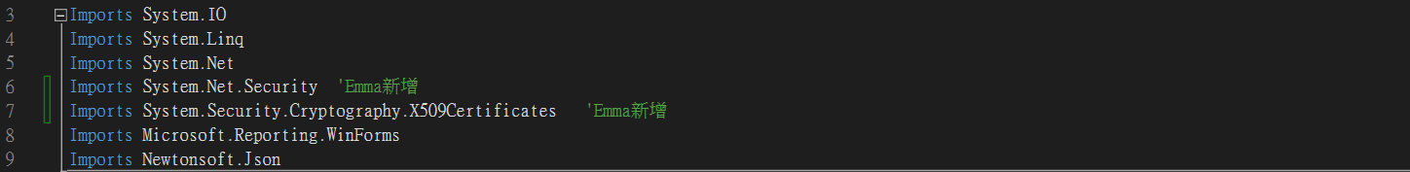  
  
**

## Test Cases

***1.21 UT：***

|  |  |
| --- | --- |
| 測試情境 | 預計結果 |
| Call API 查看回傳 | 收到回傳OK的狀態 |

***1.22 SIT：***

|  |  |
| --- | --- |
| 測試情境 | 預計結果 |
| Call API 查看回傳 | 收到回傳OK的狀態 |

***1.23 UAT:***

## Business Case

*Business justification must be supplied. Example business case reasons:*

1. *Customer requirement*
2. *Legal requirement*
3. *Expected savings - cost or FTE across a period of time (usually a year)*
4. *Other*

## Boundaries and Constraints

*Any business or technical limitations to be taken into consideration. Please include all customers, Exel sites or business units that will be affected by this modification.*

# Part 3 – Contacts (as appropriate)

|  |  |  |
| --- | --- | --- |
| Role | Name | Email |
| Developer-data source | EmmaPeng | emmapeng@eslite.com |
| Site Super User | May | **weichunliu@eslite.com** |
| Requester | 黃照能 | **joshuahuang@eslite.com** |